CHAPTER 1.0

ABSTRACT

During the early years (1960-1980) when a lot of excitement and expectations surrounded the field of Artificial Intelligence, the discovery of Neural Networks created a lot of hype and they were often believed to be the solution to the AI problem. However, with increasing research it became painfully clear that their abilities were overestimated, and they were by all means discarded, with the British government even cancelling all funding to the field.

All this changed once again in the 1980’s with the monumental discovery of the Back Propagation Algorithm, leading to a huge & sudden resurgence for the field of Neural Networks. Neural Networks have since gained popularity primarily for their ability to ‘learn’ patterns over time enabling recognition of such abstract things as voice & handwriting. Learning tasks such as these require intelligent approaches & traditional coding techniques such as rigid matching often fall very short.

That being said, the aim of this project is to implement the complex Back Propagation Algorithm and observe its learning behavior when presented with increasingly complex data sets.

This project aims to demonstrate a neural network approach to recognition of bit patterns and further implementation of these abilities to recognize text on a larger scale. Through observations of the networks learning abilities we hope to gain valuable insight into the working of these complex networks and draw inferences as to the future applications of such networks & the exciting possibilities the present.

CHAPTER 2.0

PROJECT OVERVIEW

This project aims to implement a complex neural network based on the Back Propagation Algorithm and demonstrate such a networks ability to learn characteristic patterns of bits. Such recognition activities appropriately demonstrate the networks potential for intelligent activities such as the recognition of handwritten characters.

We choose to implement the algorithm in Java rather than MATLAB, this is done so as to avoid depending on any built in functions, forcing the code to be developed from scratch. This enables us to develop a deeper understanding of the delicate mathematical intricacies of these complex networks, thereby enabling us to draw meaningful and insightful inferences with regards to the behavior of these networks under different test conditions and their application domains.

Java code for several networks, all with unique abilities, has been developed and the final network aims to learn ASCII values of characters. A network suitably trained in such tasks has the potential to recognize hand written characters, and even demonstrates the voice learning abilities of such networks.

CHAPTER 3.0

INTRODUCTION AND MOTIVATION

The motivations on selecting this topic as a project were due to the following points:
- As computers continue to invade every aspect of our lives, intelligent machines capable of handling tasks traditionally handled by humans will be the need of the hour and the focus of most research activities.

- Having said so, it clearly appears that the field of AI is the place to be & herein Neural Networks have the potential to solve complex activities, primarily those of recognition of such abstract things as handwriting and speech.

- In this regard, the potential of neural Networks is as of yet largely undiscovered & to say the least, highly underutilized.

- This project was undertaken keeping these points in mind, with the primary goal of understanding the complex inner workings of these fascinating networks and understanding the inner mathematical intricacies involved.

- We hoped to observe the complex behavior these networks display when tasked with such recognition activities, hopefully gaining enough insight to predict their behavior in their application domains.

- This we hope will help us to effectively plan for the application of such networks into bigger, more complex frameworks so as to maximize their utility

3.1 AIM AND OBJECTIVES

The aims of the system to be produced have been stated below:
- To build a system that recognizes textual data & facilitates easy extraction.
- Reduce the time required to train such a system.
- To make the system as flexible in its recognition approach as possible.
- To ensure the system is completely autonomous once trained.
- To facilitates easy training.

The Objectives of the system to be produced have been stated below:
- To implement a neural network as completely & efficiently as possible.
- To take full advantage of a neural networks flexibility & learning ability with regards to recognition of patterns.
- To ensure the system produces a low error rate despite fewer training cycles.
- To ensure such a recognition system may facilitate the autonomous extraction of textual data.
  - LITERATURE SURVEY

What is an Artificial Neural Network?
An Artificial Neural Network (ANN) is an information-processing paradigm that is inspired by the way biological nervous systems, such as the brain, process information. The key element of this paradigm is the novel structure of the information processing system. It is composed of a large number of highly interconnected processing elements (neurons) working in unison to solve specific problems. ANNs, like people, learn by example. An ANN is configured for a specific application, such as pattern recognition or data classification, through a learning process. Learning in biological systems involves adjustments to the synaptic connections that exist between the neurons. This is true of ANNs as well.

Why use neural networks?
Neural networks, with their remarkable ability to derive meaning from complicated or imprecise data, can be used to extract patterns and detect trends that are too complex to be noticed by either humans or other computer techniques. A trained neural network can be thought of as an "expert" in the category of information it has been given to analyze. This expert can then be used to provide projections given new situations of interest and answer "what if" questions.
Other advantages include:
- Adaptive learning: An ability to learn how to do tasks based on the data given for training or initial experience.
- Self-Organization: An ANN can create its own organization or representation of the information it receives during learning time.
- Real Time Operation: ANN computations may be carried out in parallel, and special hardware devices are being designed and manufactured which take advantage of this capability.
- Fault Tolerance via Redundant Information Coding: Partial destruction of a network leads to the corresponding degradation of performance. However, some network capabilities may be retained even with major network damage.

Neural networks versus conventional computers
Neural networks take a different approach to problem solving than that of conventional computers. Conventional computers use an algorithmic approach i.e. the computer follows a set of instructions in order to solve a problem. Unless the specific steps that the computer needs to follow are known the computer cannot solve the problem. That restricts the problem solving capability of conventional computers to problems that we already understand and know how to solve. But computers would be so much more useful if they could do things that we don't exactly know how to do.
Neural networks process information in a similar way the human brain does. The network is composed of a large number of highly interconnected processing elements(neurones) working in parallel to solve a specific problem. Neural networks learn by example. They cannot be programmed to perform a specific task. The examples must be selected carefully otherwise useful time is wasted or even worse the network might be functioning incorrectly. The disadvantage is that because the network finds out how to solve the problem by itself, its operation can be unpredictable.
On the other hand, conventional computers use a cognitive approach to problem solving; the way the problem is to solved must be known and stated in small unambiguous instructions. These instructions are then converted to a high level language program and then into machine code that the computer can understand. These machines are totally predictable; if anything goes wrong is due to a software or hardware fault. Neural networks and conventional algorithmic computers are not in competition but complement each other. There are tasks are more suited to an algorithmic approach like arithmetic operations and tasks that are more suited to neural networks. Even more, a large number of tasks, require systems that use a combination of the two approaches (normally a conventional computer is used to supervise the neural network) in order to perform at maximum efficiency. These features of Neural Network motivate us for carrying out character recognition using Neural network architectures.
Training Algorithms for Neural Network
Once a network has been structured for a particular application, that network is ready to be trained. To start this process the initial weights are chosen randomly. Then, the training, or learning, begins.
There are two approaches to training - supervised and unsupervised. Supervised training involves a mechanism of providing the network with the desired output either by manually "grading" the network's performance or by providing the desired outputs with the inputs. Unsupervised training is where the network has to make sense of the inputs without outside help.
The vast bulk of networks utilize supervised training. Unsupervised training is used to perform some initial characterization on inputs. However, in the full blown sense of being truly self learning, it is still just a shining promise that is not fully understood, does not completely work, and thus is relegated to the lab.

Supervised Training.

In supervised training, both the inputs and the outputs are provided. The network then processes the inputs and compares its resulting outputs against the desired outputs. Errors are then propagated back through the system, causing the system to adjust the weights which control the network. This process occurs over and over as the weights are continually tweaked. The set of data which enables the training is called the "training set." During the training of a network the same set of data is processed many times as the connection weights are ever refined.
The current commercial network development packages provide tools to monitor how well an artificial neural network is converging on the ability to predict the right answer. These tools allow the training process to go on for days, stopping only when the system reaches some statistically desired point, or accuracy. However, some networks never learn. This could be because the input data does not contain the specific information from which the desired output is derived. Networks also don't converge if there is not enough data to enable complete learning. Ideally, there should be enough data so that part of the data can be held back as a test. Many layered networks with multiple nodes are capable of memorizing data. To monitor the network to determine if the system is simply memorizing its data in some no significant way, supervised training needs to hold back a set of data to be used to test the system after it has undergone its training. (Note: memorization is avoided by not having too many processing elements.)
If a network simply can't solve the problem, the designer then has to review the input and outputs, the number of layers, the number of elements per layer, the connections between the layers, the summation, transfer, and training functions, and even the initial weights themselves. Those changes required to create a successful network constitute a process wherein the "art" of neural networking occurs.
Another part of the designer's creativity governs the rules of training. There are many laws (algorithms) used to implement the adaptive feedback required to adjust the weights during training. The most common technique is backward-error propagation, more commonly known as back-propagation. These various learning techniques are explored in greater depth later in this report.
Yet, training is not just a technique. It involves a "feel," and conscious analysis, to insure that the network is not overtrained. Initially, an artificial neural network configures itself with the general statistical trends of the data. Later, it continues to "learn" about other aspects of the data which may be spurious from a general viewpoint.
When finally the system has been correctly trained, and no further learning is needed, the weights can, if desired, be "frozen." In some systems this finalized network is then turned into hardware so that it can be fast. Other systems don't lock themselves in but continue to learn while in production use.

Unsupervised, or Adaptive Training.

The other type of training is called unsupervised training. In unsupervised training, the network is provided with inputs but not with desired outputs. The system itself must then decide what features it will use to group the input data. This is often referred to as self-organization or adaption.
At the present time, unsupervised learning is not well understood. This adaption to the environment is the promise, which would enable science fiction types of robots to continually learn on their own as they encounter new situations and new environments. Life is filled with situations where exact training sets do not exist. Some of these situations involve military action where new combat techniques and new weapons might be encountered. Because of this unexpected aspect to life and the human desire to be prepared, there continues to be research into, and hope for, this field. Yet, at the present time, the vast bulk of neural network work is in systems with supervised learning. Supervised learning is achieving results.
One of the leading researchers into unsupervised learning is TuevoKohonen, an electrical engineer at the Helsinki University of Technology. He has developed a self-organizing network, sometimes called an auto-associator, that learns without the benefit of knowing the right answer. It is an unusual looking network in that it contains one single layer with many connections. The weights for those connections have to be initialized and the inputs have to be normalized. The neurons are set up to compete in a winner-take-all fashion.
Kohonen continues his research into networks that are structured differently than standard, feedforward, back-propagation approaches. Kohonen's work deals with the grouping of neurons into fields. Neurons within a field are "topologically ordered." Topology is a branch of mathematics that studies how to map from one space to another without changing the geometric configuration. The three-dimensional groupings often found in mammalian brains are an example of topological ordering.
Kohonen has pointed out that the lack of topology in neural network models make today's neural networks just simple abstractions of the real neural networks within the brain. As this research continues, more powerful self-learning networks may become possible.

Backpropagation Learning Algorithm
The backpropagation algorithm trains a given feed-forward multilayer neural network for a given set of input patterns with known classifications. When each entry of the sample set is presented to the network, the network examines its output response to the sample input pattern. The output response is then compared to the known and desired output and the error value is calculated. Based on the error, the connection weights are adjusted. The backpropagation algorithm is based on Widrow-Hoff delta learning rule in which the weight adjustment is done through mean square error of the output response to the sample input. The set of these sample patterns are repeatedly presented to the network until the error value is minimized.
Backpropagation, an abbreviation for "backward propagation of errors", is a common method of training artificial neural networks. From a desired output, the network learns from many inputs, similar to the way a child learns to identify a dog from examples of dogs.
It is a supervised learning method, and is a generalization of the delta rule. It requires a dataset of the desired output for many inputs, making up the training set. It is most useful for feed-forward networks (networks that have no feedback, or simply, that have no connections that loop). Backpropagation requires that the activation function used by the artificial neurons (or "nodes") be differentiable.
Proposed System:

The system we propose to build takes as an input astraining datasets in the form of their ASCII values extracted from their input data. The next step is to train the network using presented input values. The next step is computation of error value and performing subsequent iterations to reduce the error. Last step is to test the Neural Network with the test dataset on successful completion of Training and Error Reduction. The system architecture is as follows:

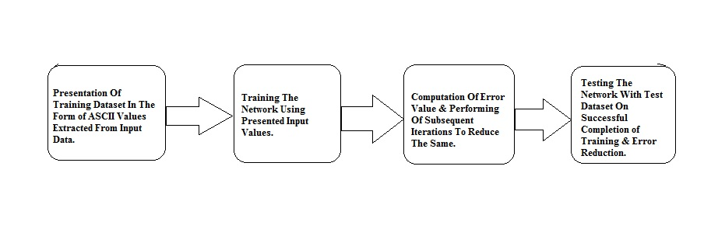Fig 4.1 Block Diagram

Methodology:

For TR, after performing the Feature Extraction we need to train the Neural Network.

Constrains of The Project:
One concern in machine learning community is that a system trained on small samples may not perform well on test data. On the other hand, if training data sets are too large, our concern is how well and efficiently a system can learn.

Large numbers of small documents vs. small numbers of large documents: Examples of scenarios using large numbers of small or moderate sized documents were given earlier (e.g., analyzing warranty or insurance claims, diagnostic interviews, etc.). On the other hand, if your intent is to extract "concepts" from only a few documents that are very large (e.g., two lengthy books), then statistical analyses are generally less powerful because the "number of cases" (documents) in this case is very small while the "number of variables" (extracted words) is very large.

Excluding certain characters, short words, numbers, etc:Excluding numbers, certain characters, or sequences of characters, or words that are shorter or longer than a certain number of letters can be done before the indexing of the input documents starts. You may also want to exclude "rare words," defined as those that only occur in a small percentage of the processed documents.

Include lists, exclude lists (stop-words): Specific list of words to be indexed can be defined; this is useful when you want to search explicitly for particular words, and classify the input documents based on the frequencies with which those words occur. Also, "stop-words," i.e., terms that are to be excluded from the indexing can be defined. Typically, a default list of English stop words includes "the", "a", "of", "since," etc, i.e., words that are used in the respective language very frequently, but communicate very little unique information about the contents of the document.

Synonyms and phrases: Synonyms, such as "sick" or "ill", or words that are used in particular phrases where they denote unique meaning can be combined for indexing. For example, "Microsoft Windows" might be such a phrase, which is a specific reference to the computer operating system, but has nothing to do with the common use of the term "Windows" as it might, for example, be used in descriptions of home improvement projects.
Stemming algorithms: An important pre-processing step before indexing of input documents begins is the stemming of words. The term "stemming" refers to the reduction of words to their roots so that, for example, different grammatical forms or declinations of verbs are identified and indexed (counted) as the same word. For example, stemming will ensure that both "traveling" and "traveled" will be recognized by the text mining program as the same word.

Support for different languages:Stemming, synonyms, the letters that are permitted in words, etc. are highly language dependent operations. Therefore, support for different languages is important.
Algorithm:
Algorithm for a 3-layer network (only one hidden layer):
- Initialize Network Weights(Random Small Values)
- Present Training Data.
- for(Specific Number of iterations)
{
for(Number of Training Examples)
{ //Forward Computation
Compute Network Output Using Current Network Weights.
Compute Error
//Backward Computation
Propagate Weight Changes From Final To Initial Layers
}
Compute Net Error
}
Test Network Using Test Dataset

As the algorithm's name implies, the errors propagate backwards from the output nodes to the input nodes. Technically speaking, backpropagation calculates the gradient of the error of the network regarding the network's modifiable weights.[2] This gradient is almost always used in a simple stochastic gradient descent algorithm to find weights that minimize the error. Often the term "backpropagation" is used in a more general sense, to refer to the entire procedure encompassing both the calculation of the gradient and its use in stochastic gradient descent. Backpropagation usually allows quick convergence on satisfactory local minima for error in the kind of networks to which it is suited.

Backpropagation networks are necessarily multilayer perceptrons (usually with one input, one hidden, and one output layer). In order for the hidden layer to serve any useful function, multilayer networks must have non-linear activation functions for the multiple layers: a multilayer network using only linear activation functions is equivalent to some single layer, linear network.

3.3 EXISTING SYSTEM

3.3.1 Google Brain:- Google Brain is an unofficial name for a deep learning research project at Google. A breakthrough in machine learning came by way of Google Brain, which consisted of 1,000 servers (16,000 CPU cores) simulating a model of the brain with a billion synapses (connections). Google Brain was trained using ten million 200x200 images unsupervised in three days. At the end, Google Brain revealed that there are two types of images that show up on the Internet quite frequently: faces and cats.

3.3.2 Nvidia’s GPU-centric approach: In response to Google Brain, Nvidia said that a billion synapses is what you'll find in a honey bee. To emulate an actual human brain, you'll need 100 billion neurons with a thousand connections each, equaling around 100 trillion connections. To train this brain using Google Brain's setup, you'll need a lot more images -- around 500 million images – and lots of time: about 5 million times longer than that of the honeybee brain setup.
Naturally Nvidia tackled this problem by developing a solution of its own. Huang said that it's now possible using three GPU-accelerated servers: 12 GPUs in total, 18,432 CUDA processor cores (Google Brain has around 16,000 cores). The Nvidia solution uses 100 times less energy, and a 100 times less cost.

3.4 SCOPE
- Neural Network must be trained using a large training set to maximize its accuracy.
- The end system should be completely autonomous.
- Primarily, the system should greatly aid in the extraction of textual data from large, unorganized data sets.

3.5 MOTIVATION
- Automation of the tedious, time consuming and error-prone task of extracting textual data from data sets of varying sizes and characteristics.
- System should be trained to recognize a wide variety of fonts and distinguish text from images, graphics and other such elements.
- Aiding the data analyst in interpreting and visualization data patterns.

CHAPTER 4.0
PROBLEM STATEMENT

Today’s text recognition engines use multiple algorithms to recognize fonts, but due to irregularities in text and font more intelligent approaches are essential.
Also due to the massive increase in available data sets and their inherent inconsistencies, recognition systems need robust training to be accurate.
Data obtained from multiple sources lacks uniformity and consistency.
An autonomous tool that can extract textual data and present it in a uniform way aiding data analysis is the need of the hour.

Literature Review
The autonomous extraction of previously unstructured and haphazard textual information from a document and its subsequent re-organization and presentation in order to assist a data analyst in the tasks of visualizing and that of deriving meaningful inferences from the contained data.
As most information (common estimates say over 80%) is currently stored as text, extraction, or mining of textual data is believed to have a high commercial potential value.
The use of neural networks for a task such as this appears appropriate, as different files and data sets will often, if not always, contain discrepancies in font and even script. Therefore, rigid approaches involving traditional algorithmic methods that lack flexibility in their operations are not apt for this task. At the same time, a fully artificial intelligent system isn’t the only solution.

CHAPTER 5.0

REQUIREMENT ANALYSIS

5.1 BLOCK DIAGRAM

Fig 5.1 System Architecture

5.2PROJECT PLANNING
The project to be undertaken has to have a certain project plan, which would serve as a structured guide for researching, designing and developing the project.

5.3SOFTWARE REQUIREMENTS

- Operating System :Microsoft Windows XP onwards
- Front end : Java
5.4HARDWARE REQUIREMENTS

- x86/x64 based PC
- Minimum 1 GB RAM

CHAPTER 6.0
PROJECT DESIGN

6.1 FUNCTIONAL REQUIREMENTS: (DFD)

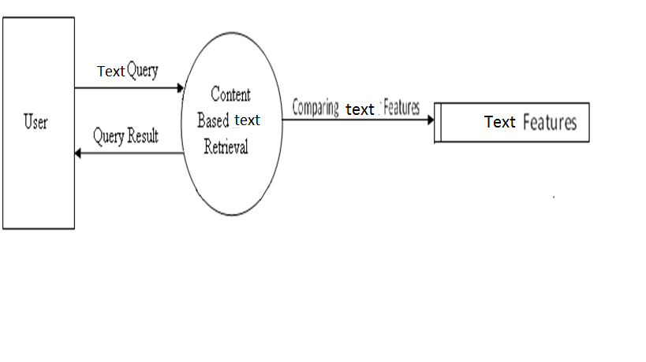

6.2 UML DIAGRAMS

    - USE CASE DIAGRAM

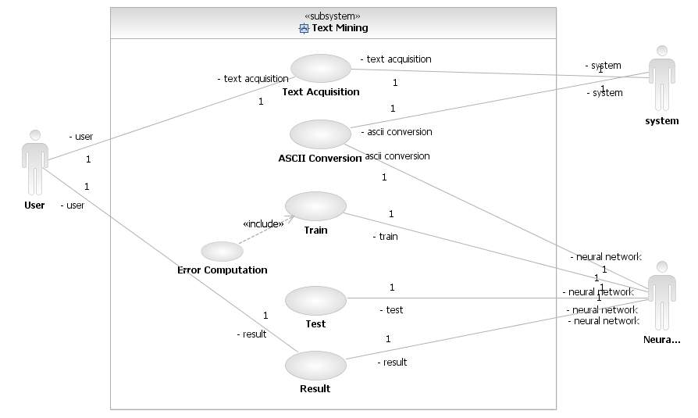

Sr. No. | Actors | Use Case Description
1 | User | - Provides Text  - Receives Segmented Text  - Provides the text to Neural Networks  - Receives Result
2 | System | - Acquires & Selects Text  - Segments Text
3 | Neural Networks | - Extracts Features  - Recognizes Text  - Provides Result

    - CLASS DIAGRAM

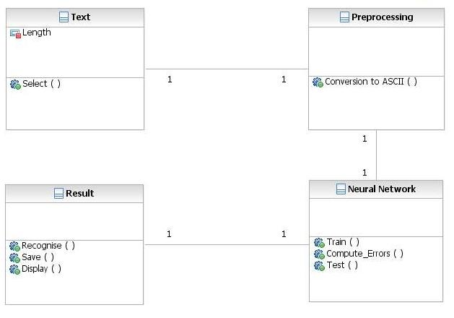

    - ACTIVITY DIAGRAM

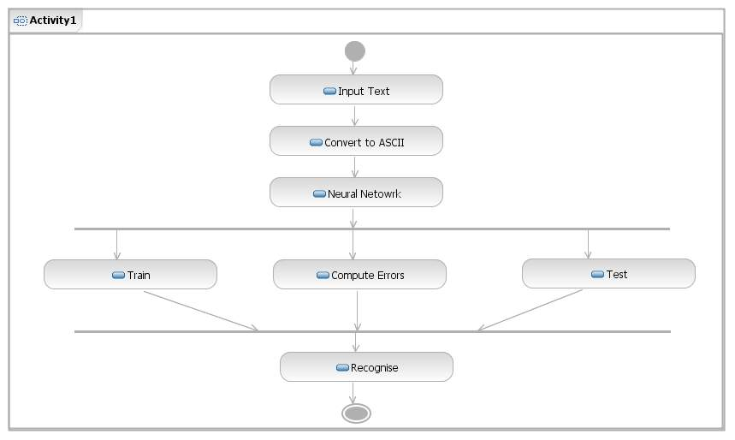

    - STATE DIAGRAM

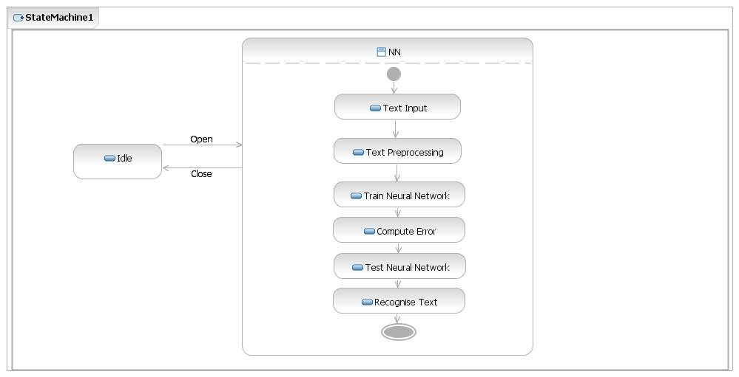

COMPONENTS:

States
States represent situations during the life of an object. You can easily illustrate a state in SmartDraw by using a rectangle with rounded corners.
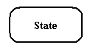

Transition
A solid arrow represents the path between different states of an object.Transition with the event that triggered it and the action that results from it.
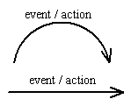

Initial State
A filled circle followed by an arrow represents the object's initial state
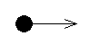

Final State
An arrow pointing to a filled circle nested inside another circle represents the object's final state.
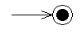

    - SEQUENCE DIAGRAM

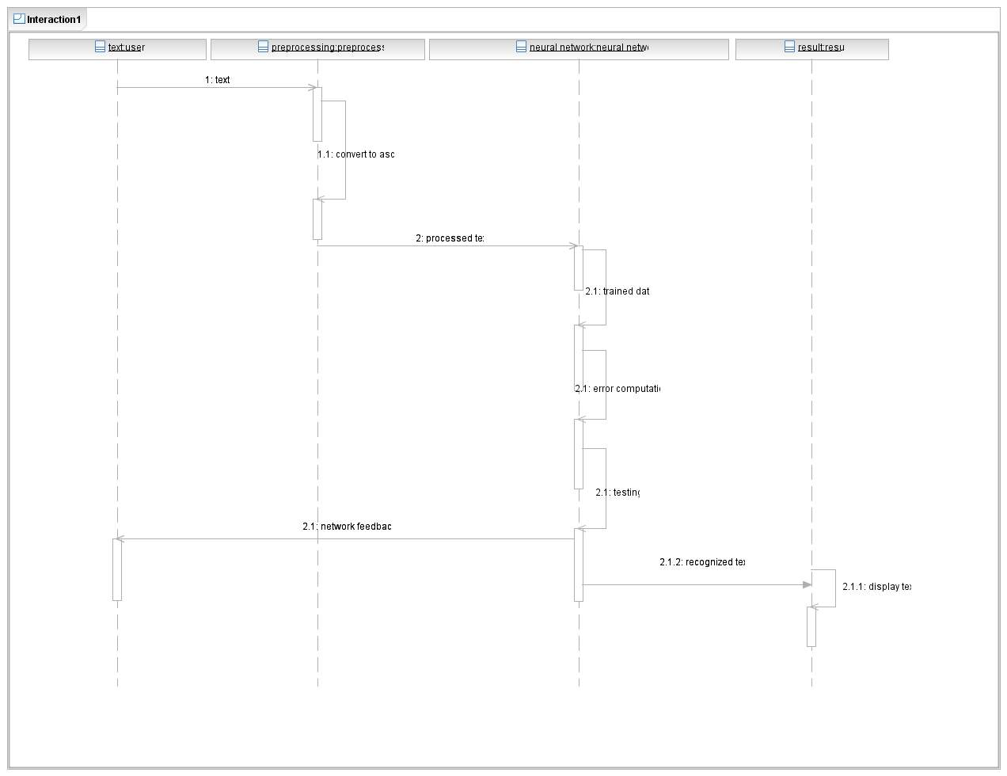

CHAPTER 7.0
IMPLEMENTATION DETAILS

7.1 Interface Design

Training Input Page:-

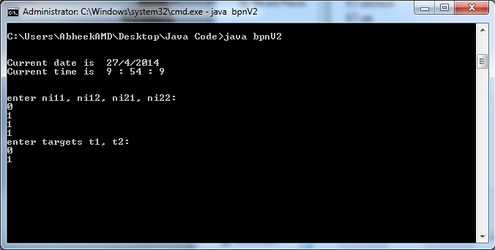

Training Page:-

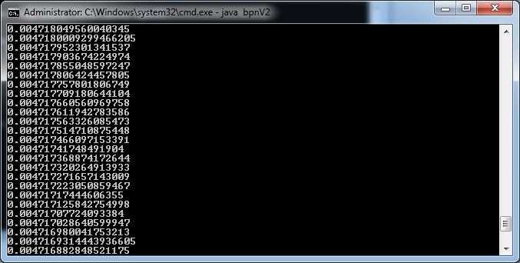

Training Page:-

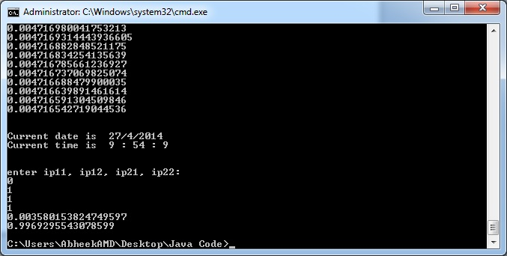

Training Input Page:-

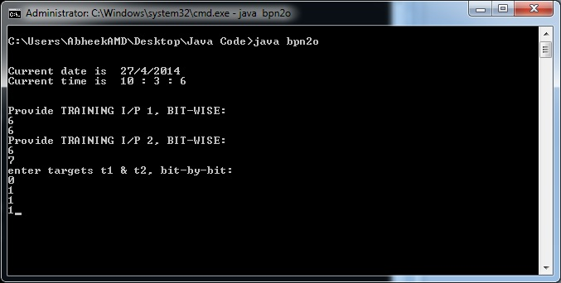

Testing Page:-

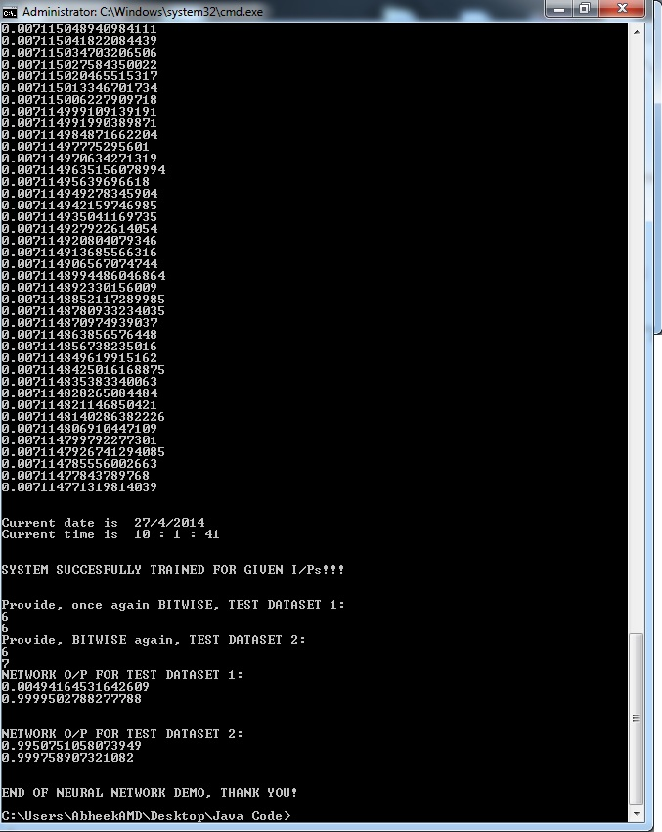

Interface Page:-

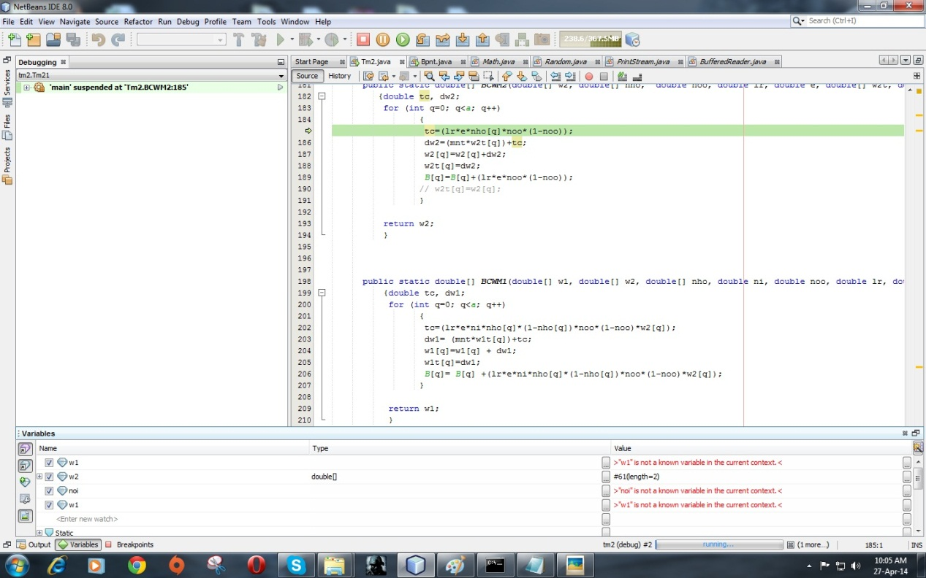

Interface Page:-

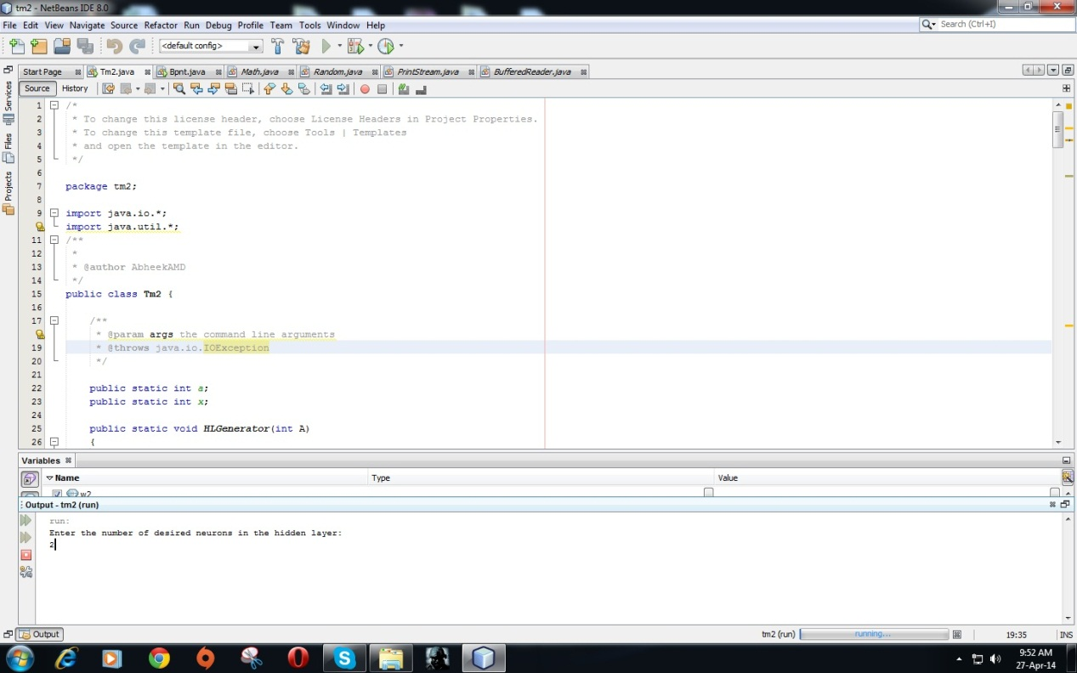

CHAPTER 8.0
TECHNOLOGIES USED
- Java Compiler & Run time Environment & Java Development Kit: Used for core code development activities.
- Netbeans Integrated Development Environment:Used for debugging code & cross checking output.
- MATLAB: Reference source for built in Neural Network toolbox.

CHAPTER 9.0
TEST CASES

1)

2)

3)

4)

5)

CHAPTER 10.0

PROJECT TIME LINE

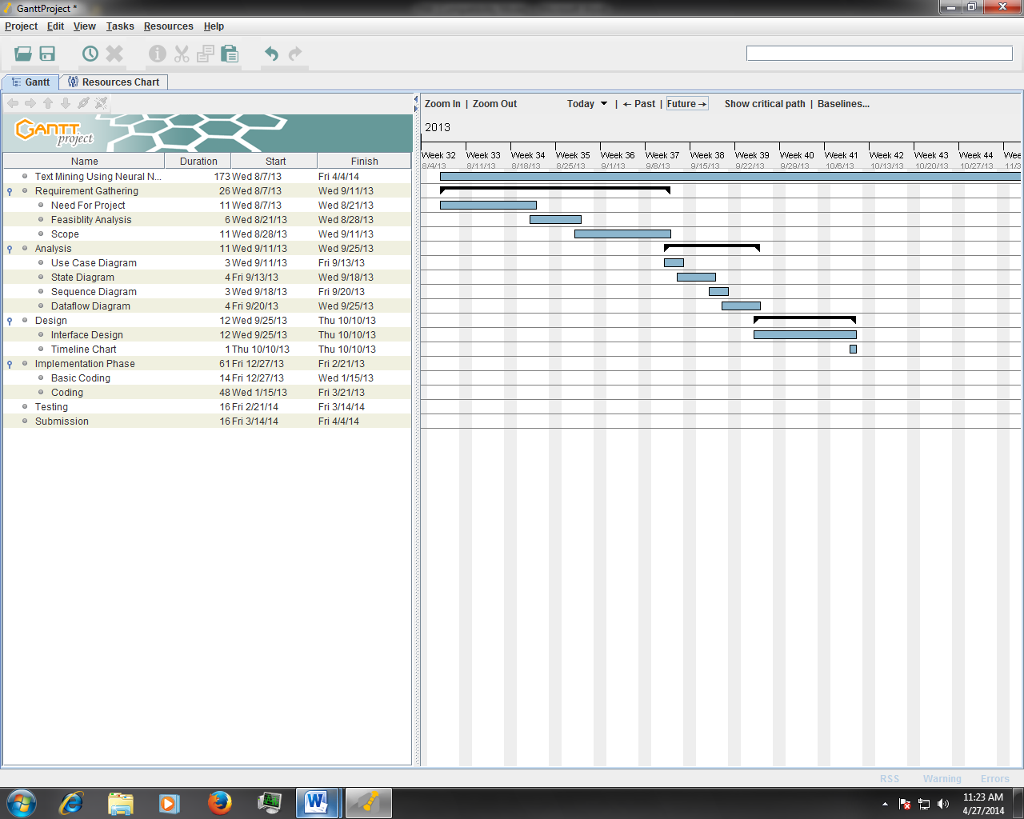

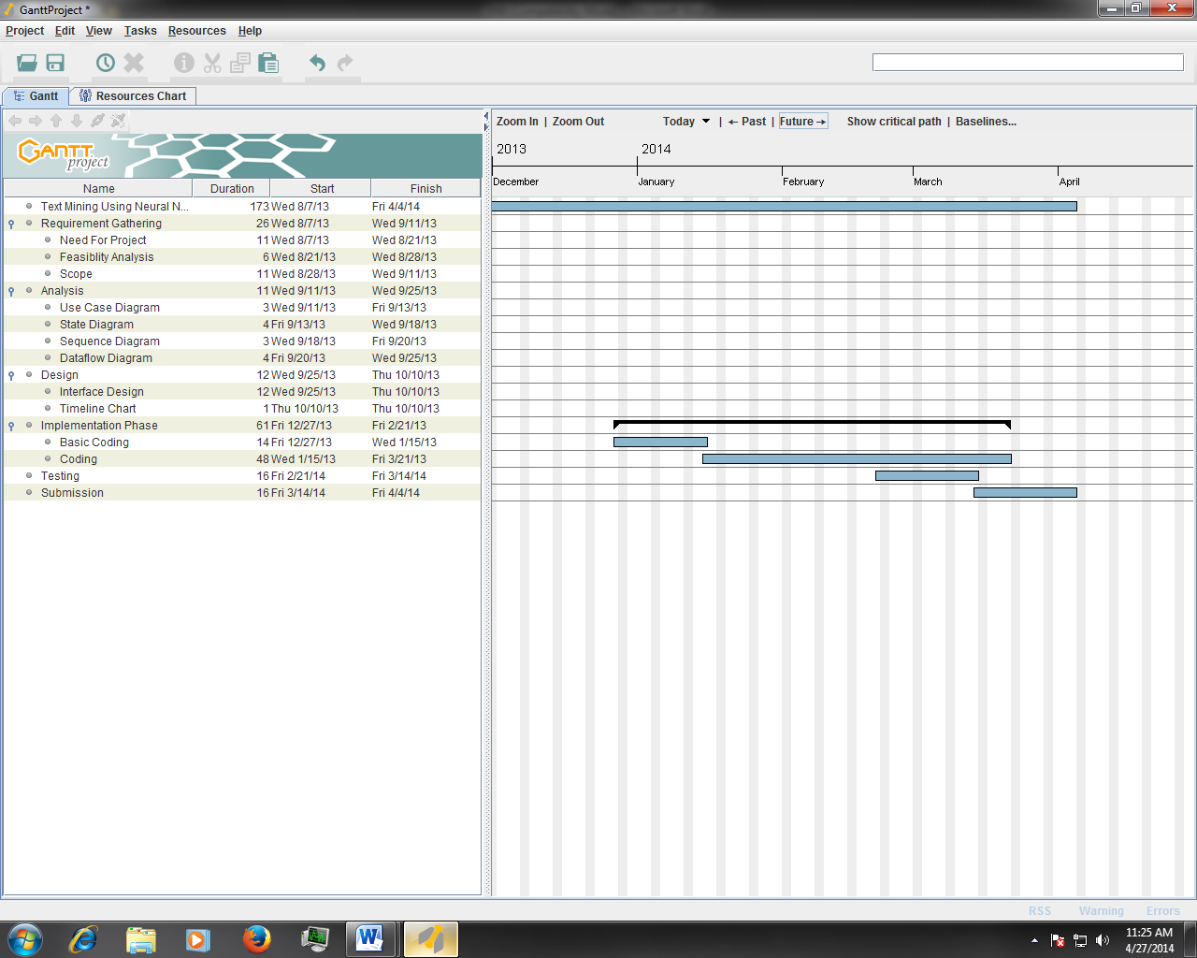

CHAPTER 11.0

TASK DISTRIBUTION

1. Effective Pattern Discovery For Text Recognition
1.1 Analysis
1.1.1 Input Text
1.1.2 Preprocess Image
1.1.3 Error Computation
1.2 Documentation
1.2.1 Synopsis
1.3 Design
1.3.1 Identify Design Pattern
1.3.2 Identify Design Modules
1.4 Coding
1.5 Testing

1.4.1 Frontend and Backend
1.4.2 Code Preprocess Module
1.4.3 Code Training Module

1.5.1 Preparation of Test Plan

1.2.2 Software Requirement Specification
1.5.2 Create Test Data

1.3.3 Design Module in Detail
1.5.3 Setup Test Environment

1.2.3 Black Book

1.1.4 UML Diagrams
1.3.4 Development Methodology
1.5.4 Test Execution

1.4.1 Code Text Recognition Module

1.1.5 Specify Project Goals
1.5.5 White Box Testing

1.5.6 Black Box Testing

1.5.7 Implementation and Maintenance

CHAPTER 12.0

CONCLUSION & FUTURE WORK

We draw the conclusion that neural networks are a viable option for the recognition and extraction of unstructured textual data due to their learning capabilities & lack of rigidness.
A System can be built that successfully recognizes characters and thus fits into a larger sophisticated text mining & character recognition platform.

CHAPTER 13.0

REFERENCES

Bibliography and References

[1] M. Govindarajan, and R. M. Chandrasekaran, “Classifier Based Text Mining for Neural Network,” World Academy of Science, Engineering and Technology 27 2007.

[2] CatalinI.Tomai, Bin Zhang and SargurN.Srihari, “Discriminatory Power of Handwritten Words for Writer Recognition,” Proceedings of the 17thInternational Conference on Pattern Recognition (ICPR’04).

[3] Marius Bulacu, and Lambert Schomaker, “Text-Independent Writer Identification and Verification Using Textural and Allographic Features,” IEEE Trans. Pattern Analysis and Machine Intelligence, vol. 29, no.4, April 2007.

[4] R.Plamondon and S.N.Srihari. “Online and Offline Handwriting Recognition: A Comprehensive Survey,” IEEE Trans. Pattern Analysis and MachineIntelligence, vol. 29, no.1, Jan. 2000.

CHAPTER 14.0
APPENDIX

14.1 GLOSSARY:

- Neural Networks: Complex mathematical models used to model the inner working of the most complex object designed by nature: The Human Brain.

- Java: Programming language popular for its platform independence & object oriented nature.

- Netbeans IDE: An integrated development environment used to develop and debug code.

- MATLAB: MATrix LABoratory, complex engineering software with a built in Neural Network toolbox used to observe and visualize the functioning of neural networks.

14.2 ACRONYMS & ABBREVIATIONS:

ANN | Artificial Neural Networks
ANSI | American National Standards Institute
BPM  DPI | Bitmap  Dots Per Inch
ECMA | European Computer Manufacturers Association
FFNN | Feed forward Neural Network
Gb | Giga byte
GHZ | Giga Hertz
GIF  ISO | Graphic Interchange Format  International Standards Organization
JPEG/JPG  MATLAB | Joint Photographic Expert Group  Matrix Laboratory
M-files | Matlab Files
NN | Neural Networks
NNT | Neural Networks Toolbox
CR  OS | Character Recognition  Operating System
PDF | Portable Document  Format
RTF | Rich Text Format

